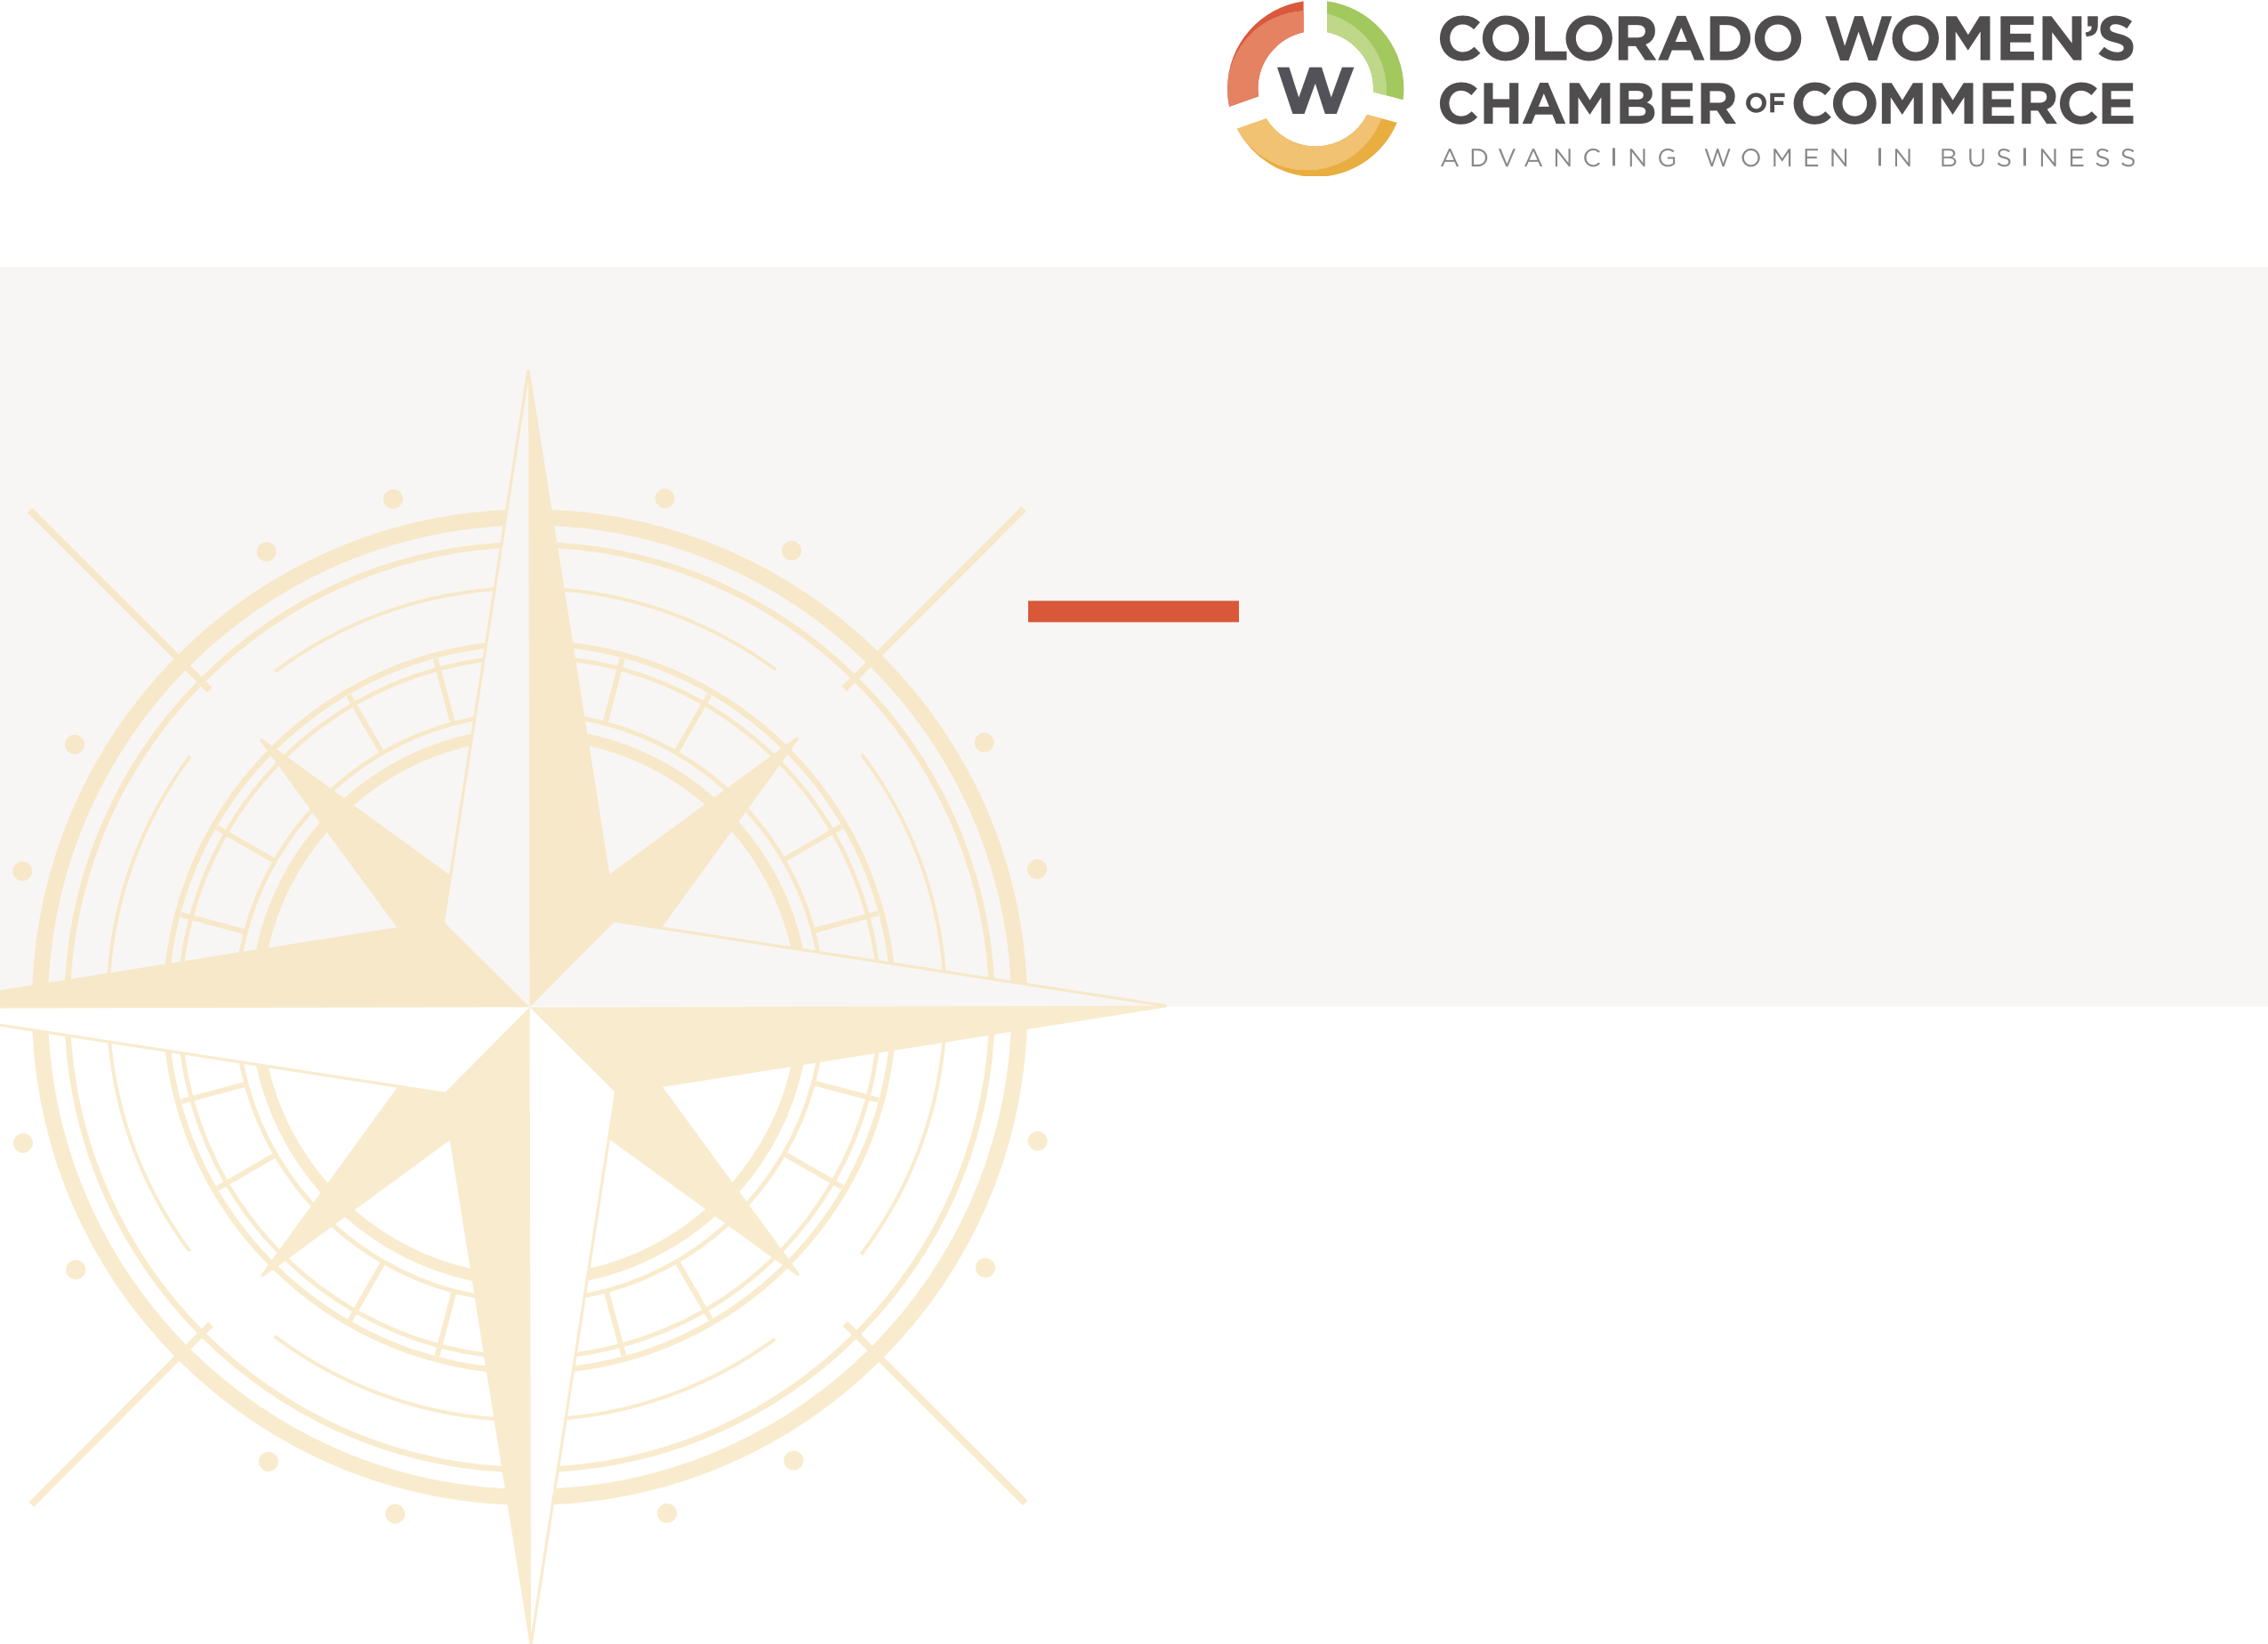
WOMEN OF IMPACT AND INFLUENCE

A Leadership Program
As leaders, women are still struggling to get to the very top. A staggering 86% of woman-owned businesses have only one employee, we make up only 14% of CEOs, and Colorado is nearly last in the nation for the number of women on publicly traded boards.
THE COLORADO WOMEN’S CHAMBER IS WORKING TO CHANGE THESE STATISTICS FOR WOMEN IN BUSINESS.
Are you an emerging leader?
Do you have a desire to lead and influence your community? Are you eager to learn and build relationships with other like-minded, professional women?
THEN THIS PROGRAM IS FOR YOU.

Join the Colorado Women’s Chamber of Commerce’s WOMEN OF IMPACT AND INFLUENCE LEADERSHIP PROGRAM to grow in business, build a strong network of powerful women, and tap into higher levels of community engagement on issues that affect women.
D I V E D E E P I N TO TO PI C S T H AT WI LL S H A PE YO U R F U T U R E :

- Increase your understanding of issues that impact today’s leaders.
- Learn about growing industries from C-suite female leaders in those industries.
- Become more confident in the following leadership areas:
-Advocating for Promotion
-Change Management
-Negotiation

“I’ve definitely grown more confident in my own leadership skills in the few months of participating in the CWCC’s Women of Influence and Impact. I’ve been forced out of my comfort zone on several occasions and that has given me the confidence to venture out of my comfort zone back at work.”
— Jessica Hudgins, Goodwill Industries of Denver, Class of 2017-2018

“One of the best parts of the program was the ability to connect with other like-minded,
inspirational women!”
— Jennifer Case, Vectra Bank

OUR NEXT COHORT
BEGINS OCTOBER 2019.

NAME _________________________________________________________________ TITLE/POSITION _______________________________________________________ COMPANY _____________________________________________________________ EMAIL _________________________________________________________________
Applications must be received by September 6th, 2019. Participation fees are due upon approval of application.
An invoice will be sent via email. Please send completed application to hhowerton@cwcc.org.

Application
WOMEN OF IMPACT AND INFLUENCE
PHONE _______________________________________________________________

- How would you describe community involvement and how do you engage in that space? This could include volunteer projects, board service, Chamber participation, etc.
- Have you ever participated in a Leadership Program before? What aspects of this program really resonate with you? Tell us about your learning style?
- How many people do you manage? What are your top three leadership challenges
- What are you hoping to gain out of this leadership program? What are you hoping to contribute?

Please initial your agreement to the following policies:
____ I have a current CWCC membership. Please note – must be an active CWCC member to participate in the program.
____ I agree not to miss more than TWO classes during the program or leave early/arrive late more than twice.
_____I agree to $2,000 investment to participate or my membership dues includes one seat in this program.

